

**Course Title:** CSE110

**Section:** 06

**Semester:** Summer 22

**LAB-07**

**SUBMITTED TO**

Mahamudul Hasan

Department of Computer Science & Engineering

East-West University

***SUBMITTED BY***

**Name:** B M Shahria Alam

**Student ID:** 2021-3-60-016

**Date of submission:** 15 August 2022.

A)

import java.util.ArrayList;

import java.util.Scanner;

abstract class Shape {

private double area ;

public void setArea(double area)

{

this.area=area;

}

public double getArea()

{

return area;

}

abstract void rectangleArea(double length, double breadth);

abstract void squareArea(double side);

abstract void circleArea(double radius);

}

class Area extends Shape

{

void rectangleArea(double length, double breadth)

{

double area=length * breadth;

this.setArea(area);

System.out.println("The area of the rectangle is: "+this.getArea());

}

void squareArea(double side)

{

double area= side * side;

this.setArea(area);

System.out.println("The area of the square is: "+this.getArea());

}

void circleArea(double radius)

{

double area= 3.1416 * radius * radius;

this.setArea(area);

System.out.println("The area of the circle is: "+this.getArea());

}

}

public class AbstractClassTest {

public static void main(String[] args)

{

Scanner in=new Scanner(System.in);

ArrayList<Shape>scapearray= new ArrayList<>();

System.out.println("How many shape do you want to create:");

int n=in.nextInt();

for(int i=0;i<n;i++)

{

System.out.println("Press(1): for 'Rectangle'");

System.out.println("Press(2): for 'Square'");

System.out.println("Press(3): for 'Circle'");

System.out.println("\nShape no:"+(i+1));

int x=in.nextInt();

if(x==1)

{

System.out.println("Enter the length of the rectangle:");

double lenght= in.nextDouble();

System.out.println("Enter the breadth of the rectangle:");

double breadth= in.nextDouble();

Shape area=new Area();

scapearray.add(area);

scapearray.get(i).rectangleArea(lenght,breadth);

}

else if(x==2)

{

System.out.println("Enter the side of the square:");

double side= in.nextDouble();

Shape area=new Area();

scapearray.add(area);

scapearray.get(i).squareArea(side);

}

else if(x==3)

{

System.out.println("Enter the redius of the cirlce:");

double redius= in.nextDouble();

Shape area=new Area();

scapearray.add(area);

scapearray.get(i).circleArea(redius);

}

}

}

}

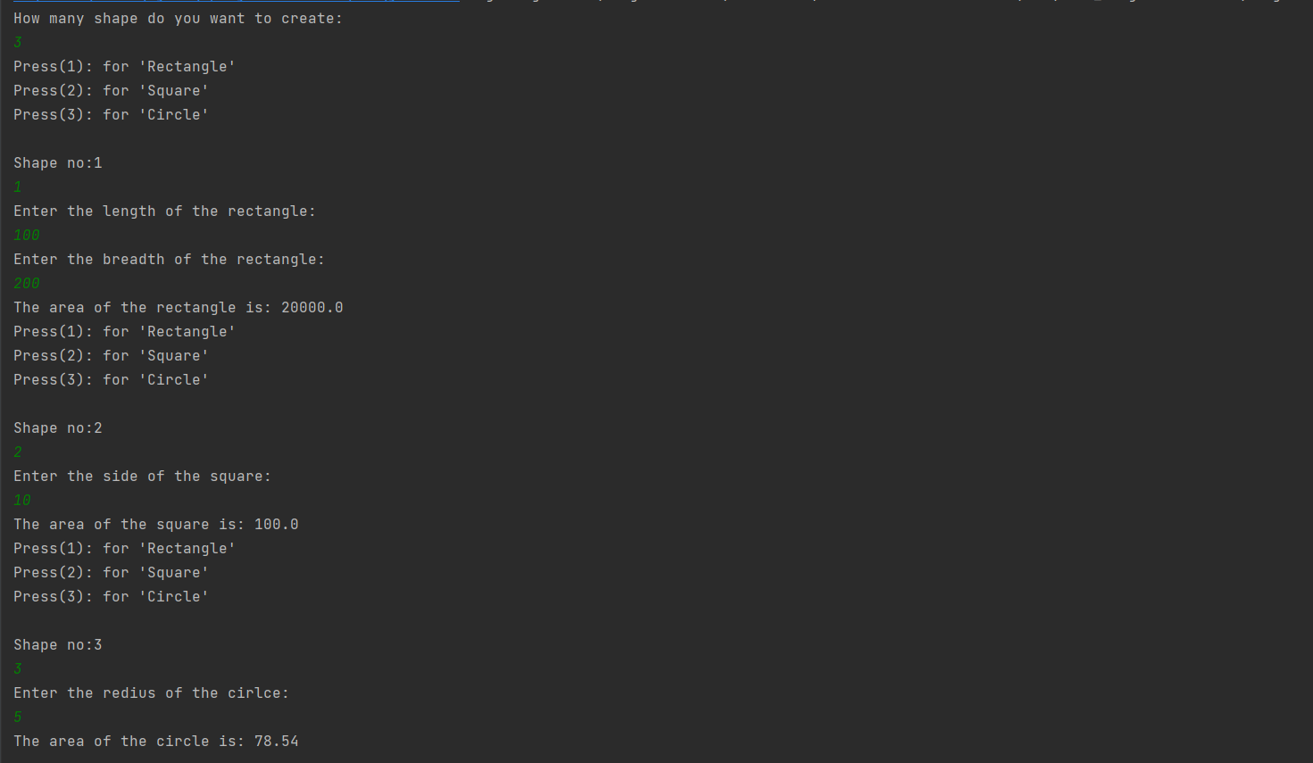

B)

import java.util.ArrayList;

import java.util.Scanner;

public class ArrayListTest {

public static void main(String[] args)

{

Scanner in=new Scanner(System.in);

ArrayList<ArrayList>List= new ArrayList<ArrayList>();

System.out.println("Enter the number of lines:");

int x=in.nextInt();

System.out.println("Enter the number of integer:");

for(int i=0; i<x;i++)

{

ArrayList<Integer>intList= new ArrayList<Integer>();

int y=in.nextInt();

for(int j=0;j<y;j++)

{

intList.add(in.nextInt());

}

List.add(intList);

}

ArrayList<Integer>line= new ArrayList<>();

ArrayList<Integer>index= new ArrayList<>();

System.out.println("Enter the number of queries:");

int q=in.nextInt();

for(int i=0;i<q;i++)

{

int a=in.nextInt();

int b=in.nextInt();

line.add(a);

index.add(b);

}

System.out.println("Output:");

for(int i=0; i<q;i++)

{

if(index.get(i)>List.get(line.get(i)-1).size())

{

System.out.println("ERROR!");

}

else

{

System.out.println(List.get(line.get(i)-1).get(index.get(i)-1));

}

}

}

}